 | School of Electrical and Information Engineering  University of the Witwatersrand, Johannesburg  ELEN4002/4012: Project Specification Outline | To be completed by supervisor  Assessment:  ☐ Deficient ☐ Acceptable  ☐ Good ☐ Excellent

Project Title: | Image compression based on non-parametric sampling in noisy environments

Group Number: | 19G01 | Supervisor Name: | Prof. Fambirai Takawira
Student Name A: | Kishan Narotam | Student Name B: | Nitesh Nana
Student Number A: | 717 931 | Student number B: | 720 064

Ethics: ☐ Request for waiver (does not involve human participants or sensitive data)
_________________ ☐ Copy of ethics application attached (Non-medical) – School Committee
Supervisor Signature ☐ Copy of ethics application attached (Medical) – University Committee

Project Outline: (give a brief outline such that ethics reviewers understand what will be done, 100 words maximum)
A variety of images will be transmitted via a channel and received after being processed in noisy environments, with the ultimate goal of image compression. The proposed method includes creating holes within the image and transmitting through the channel. The image is received at the receiver and processed in order to fill the holes resulting in the structure of the original image.

Project Specification:
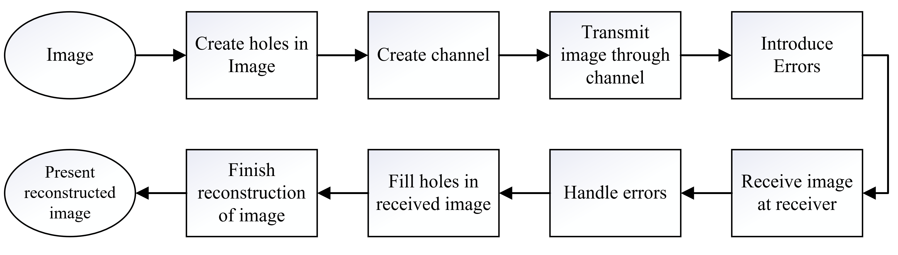
An image will be chosen for compression utilizing the compression technique of creating holes in the image and after transmitting, filling of those holes will result in the original image.
(The creation of holes results in the compression of the original image).
The holes will be created manually making use of current compression algorithms (such as fractal compression for example). Once the holes are created, the image will be transmitted via a simple channel that will introduce errors randomly.
The image will be received at the receiver, and knowing where the holes are present, will fill them accordingly using a different algorithm. The receiver will also have to deal with random errors that may have occurred from the channel. The received image with the filled holes will be reconstructed and presented as the final image which should coincide with the original image.

Should time be permitting, alternate compression algorithms (e.g. DCT) will be utilized on the same image and used as a way of comparing the created holes compression technique with a common practice compression technique (similar to DCT for image compression for JPEGs).

Milestones: |  | Preliminary Budget & Resources:
The initial goal would be to complete a literature review before the commencement of the project and have a plan on which specific algorithms will be implemented.  The algorithm for creating holes in the image will take roughly one and a half weeks to complete. This will be completed in parallel with setting up the channel necessary for transmitting images.  Introducing errors is estimated to take half a week of time.  Handling errors and filling of holes will be completed in parallel and is estimated to take around 2 and a half weeks to complete.  One week is set out for debugging and refining of algorithms,  The remaining time is allocated to documentation and report writing.  Some tasks may be divided between members in order for them to be completed in parallel. For example, each person may work individually on different parts of the holes algorithm and combine workings later on. |  | Budget:  No budget is required and personal  laptops/computers will be utilized.  Resources:  Since this project requires no physical  hardware building, only computers will be utilized in implementing the algorithms and processing the images.  The various programs used to implement the  algorithms will require the relevant software  licenses (most probable is MATLAB).  Student licenses provided by the university.  Processing the images, will require the actual  images (image data), these could range from  textured images to some more complex.

Risks / Mitigation:
- Using images available from the web may lead to intellectual property and copyright infringements. To mitigate this risk, only approved data labeled for reuse will be utilized.
- University protest action may cause unforeseen interruptions. Having laptops and due to the nature of the project, working on campus grounds is not an absolute necessity and work may be completed in a different environment.
- Eskom’s current power crisis may result in data corruption as everything will be done on computers. However, since laptops will be utilized, this may be prevented, but laptops have a limited battery life and so work must be saved throughout the process of image compression and broken down into smaller, more manageable segments that can be completed in shorter cycles.

